**“Y’all Livin to 80”**

**Decomposing changes in life expectancy in the United States**

Replication and Extension for the paper “*Decomposing changes in life expectancy: Compression versus shifting mortality*”

**“Y’all Livin to 80”**

**Decomposing changes in life expectancy in the United States**

**Introduction**

Since the 19th century, life expectancy has been improving at a rate of three months per year for the most longevous populations (Oeppen & Vaupel 2002). For high-income countries, the improvements in life expectancies have been steady throughout the past two centuries (Vallin & Mesle 2009; Vaupel et al., 2011). However, the force that derives the growth in life expectancy is still unclear. Demography, as a discipline, has put the focus on the driving force of life expectancy growth on the contributions from different age groups and different dimensions of mortality changes (Andreev et al., 2003; Horiuchi et al., 2008). Past research has emphasized that mortality reductions at infant ages, and subsequently adolescents have been the major driving force of life expectancy improvements up until the 1950s (Omran, 1971; McKeown, 2009). Since then, life expectancy kept a steady growth for the majority of high-income countries, with the contributions to life expectancy growths shifted from younger ages to older ages (Canudas-Romo, 2010; Aburto et al., 2020). Many researchers set to understand this phenomenon with multiple theories proposed to explain the change of such. Fries (1980) first developed the theory of mortality compression, which states as successful mortality reductions are carried out at younger ages, the mortality will be compressed into specific older ages. Meanwhile, scholars have suspected that there is more than one aspect of mortality changes that are driving the changes in life expectancy. One supplementary theory that was later proposed by Canudas-Romo (2008) looks at the shift of death distribution and its relations to changes in life expectancy, or mortality shift theory. The death distribution (or age-at-death distribution) can be seen as a left-skewed distribution (Preston et al., 2000). The changing mode of the death distribution, defined as the modal age at death, shares a close association with the changes in life expectancy in recent decades (Canudas-Romo, 2008).

Many studies have been focusing on examining empirically the validity of the two theories that relate to mortality change and life expectancy change (Jassen & de Beer, 2019; Wilmoth & Horiuchi, 1999; Ouelette et al., 2013). Among them, two papers succeeded in showing how mortality compression and mortality shifts contribute to changes in life expectancies simultaneously (Basellini et al., 2019; Bergeron-Boucher et al., 2015). The paper by Bergeron-Boucher et al. (2015) used a decomposition method that relates death distribution and changes in life expectancy with mortality modelling to examine the contributions from mortality compression and mortality shift. The results show that up until 2010, most life expectancy growths among high-income counties since the 1950s are driven by the mortality shift, meaning more people are living to older ages.

Among the countries examined by Bergeron-Boucher et al. (2015) is the United States (hereafter the US). In the studies by Bergeron-Boucher et al. (2015), the US is one of many countries that are experiencing steady increases in life expectancy. However, the study has only included mortality data up until 2010, a decade away from now. In the recent decade, the US has been going through challenges in reducing mortality at all ages due to the deaths inflicted by the deaths due to violence or accidents (Shkolnikov et al., 2011), and deaths related to the poor healthcare system (Dwyer-Lindgren et al., 2016), and more recently by the opioid epidemic (Case & Deaton, 2021). This might seriously impact the progress made by mortality shift and mortality compression. These challenges have put the United States in a relatively disadvantaged position compared to other high-income countries in terms of life expectancy (Avendano & Kawachi, 2014; Ho & Hendi, 2018). Life expectancy in the United States has stagnated and fallen behind its other high-income country peers in recent years (Woolf et al., 2019). New evidence for the past decade is needed to further assess the hidden dynamics that drive the changes in life expectancy in the United States. At the same time, more evidence is needed to assess how the future of life expectancy growth will hold, especially since the beginning of the COVID-19 pandemic. This would benefit in answering the question: What the future holds in life expectancy change for the US? Is it an unavoidable demise or is there a silver lining after all?

Apart from concerns about the mortality changes at the national level. There are now pessimistic views on the current state and the future of life expectancy for the US after the impact of the COVID-19 pandemic in recent years due to massive inequalities in mortality for different races, and between rich and poor (Aburto et al., 2022; Woolf et al., 2022). This sub-national perspective that compares the sub-populations with the national average is desperately needed during the COVID-19 pandemic to provide timely and vital messages regarding disadvantaged populations (see e.g. Basellini & Camarda, 2022; Schlüter et al., 2022; Woolf et al., 2021). At the same time, new evidence generated from this extension will further quantify the excess mortality within the US in terms of different racial groups or socioeconomic groups (see e.g. Preston & Vierboom, 2021). Therefore, this study seeks to examine the changes in life expectancy and the effects of various components for different racial groups in the US from 2011 to 2020. And by extending the Bergeron-Boucher et al. (2015) paper to sub-national populations, answering the question: How do the changes in life expectancy among sub-populations in the US differ from the national level in recent years?

**Data**

The data used in this study consists of two parts. We first retrieved the mortality rates and population exposure by single-year age from age 30 to age 110, which is essential in mortality modelling, from the Human Mortality Database (HMD). The HMD is a harmonized mortality database of 48 countries over a long series of times. This high-quality database enables us to make comparisons of mortality outlook across time and populations. For the United States national population, the mortality data coverage spans from 1933 to 2020. For the comparison of mortality data across different races and ethnicities from 2011 to 2020, we obtained the number of deaths and mid-year population (a proxy for population exposure) for Blacks, Native Americans, and Non-Hispanic whites at each age from the National Centre of Health Statistics (NCHS) via the CDC Wonder platform. The NCHS data for the United States national population is also the raw input data for the HMD in most cases. The population exposure for the US data by race is smoothed using the penalized composite link model since the original data are in coarsed age group (for details see Rizzi et al., 2015).

**Methods**

**Life Expectancy**

Life expectancy is a measure widely adopted in demographic and public health research (Luy et al., 2020; Modig et al., 2020). Life expectancy measures the average years of life a population would expect to live if they follow the age-specific mortality of a given year (Preston et al., 2000). Based on the definition, life expectancy can summarise the health outlook of a population in terms of years. Life expectancy ($e_{0}$) is constructed with age-specific mortality ($μ_{x}$) which is expressed as:

$e_{0}=\int_{0}^{ω}{l_{a}}=\int_{0}^{ω}{\exp\left(-\int_{0}^{a}{μ_{x}}dx\right)da,}$ (1)

with the function $l_{x}$ represents the life table survival function. The age-specific mortality ($μ_{x}$) can be modelled using mortality modelling to approximate value in a continuous framework. The changes in life expectancy across time convey the message of whether a population is doing better or worse in terms of population health outlook compared to its previous self. In this study, we will use the remaining life expectancy at age 30, which is the average life years the population aged 30 is expected to live.

**Mortality Models**

Ever since John Graunt established the scientific studies in human mortality with mathematics and statistics, the law that underlies the age pattern in human mortality has intrigued scientists in recent centuries. This fascination comes from the fact that the mortality rate observed at each age empirically, as recorded by the statistical office and health authorities, are in nature discrete, with deaths being grouped into each broad age group. However, mortality in real life is in nature continuous since deaths could occur at any time within the broad age groups. Therefore, understanding the pattern that mortality progresses from younger to older ages will help in producing better estimates of the population's health outlook.

One foundational principle that Graunt has established is that the mortality risks grow as adults age (Connor, 2022). The tradition of modelling mortality age patterns started with Pioneers like Gompertz (1825), and Makeham (1867), among others (for a detailed summary see Tabeau, 2001). The seminal work of Gompertz affirmed a universal law that has been observed throughout human history that mortality risk grows exponentially as humans age from 30 to around age 90. This pattern can be modelled with a logarithmic age-specific mortality rate ($log⁡(μ_{x})$) beyond age 30 as a linear line. Makeham further extends this linear model, adding a component that associates with deaths that are extrinsic to the adult ageing process.

Although these models provided useful information for the understanding of human mortality across different ages in a continuous framework, there are still shortcomings of these models to infer more insights into the age dynamics of mortality. For example, the mortality model parameters have relatively high correlations within them, and at the same time, some parameters have ambiguous interpretations regarding the process of ageing (Missov et al., 2015). To address these shortcomings, Horiuchi et al. (2013) have re-parameterised the three models mentioned above with the introduction of modal age at death. Modal age at death refers to the age where the number of deaths is the highest across the age-at-death distribution (Canudas-Romo 2008). The introduction of modal age at death relates the age pattern of mortality to the death distribution, two important theoretical instruments for demographers. Therefore this endeavour has shed light on the possibility of utilizing mortality models to examine the dynamics of mortality changes such as changes in life expectancy (see e.g. Bergeron-Boucher et al., 2015; Basellini et al., 2019).

In our analysis, we utilized the Gompertz-Makeham model (Horiuchi et al., 2013), with age-specific mortality at each age ($μ_{x}$) modelled as an exponential function:

$μ_{x}=c+β*\exp\left(β\left(x-M\right)\right).$ (2)

In this equation, parameter $c$ denotes the extrinsic mortality (or background mortality) that doesn’t increase with age (e.g. causes of mortality such as accidents, suicides, and poisoning), and the parameter $β$ represents the level of mortality as the studied population ages (at the same time, $\frac{1}{β}$ also shows the degree of mortality is concentrated in one age, see Vaupel, 1986). The parameter $M$ in equation (2) stands for the modal age at death for the studied population, which shows the shift in mortality in older ages with $x$ representing age. The age-specific mortality is the result of three age-independent fitted parameters $c$, $β$, and $M$, as well as an age parameter variable $x$, which takes the value from 30 to 110.

We used the Gompertz-Makeham model to derive mortality rates based on the number of deaths at each age and population exposure at each age. Our model can be estimated with the maximum likelihood method which assumes the number of deaths at each age follows a Poisson distribution (Brillinger 1986; Missov et al., 2015). The details of the maximum likelihood estimation can be found in the ***Appendix***.

**Decomposition Methods**

Decomposition methods have a long history in Demography and other social and biological science disciplines (for a summary see Canudas-Romo 2003). Decomposition methods attribute changes or differences in a demographic function into meaningful components that can be compared across time or among different populations. This procedure is done by taking derivatives with respect to time on the demographic function in question, in our case life expectancy. Let a dot on top of a function denote the derivatives with respect to time (Newton notation, see e.g. Newton 1704), the mathematical equation writes:

${\dot{e}}_{0}=\int_{0}^{ω}{{\dot{l}}_{a}}da=-\int_{0}^{ω}{l_{a}\int_{0}^{ω}{{\dot{μ}}_{x}}dx}da.$ (3)

This equation can also be found in Vaupel & Canudas-Romo (2003), Cui et al. (2019), etc.

Since we have introduced equation (2) of estimating the age-specific mortality ($μ_{x}$) with Gompertz-Makeham model. By taking the derivatives of equation (2) and then plugging them into equation (3), we can decompose changes in life expectancy into the following additive components:

${\dot{e}}_{0}=\underbrace{-\dot{c}\int_{0}^{ω}{l_{a} a da}}$

$\underbrace{-\dot{β}\int_{0}^{ω}{l_{a}\int_{0}^{a}{\left[\exp\left(β\left(x-M\right)\right)\left(1+β\left(x-M\right)\right)\right]}}}$

$\underbrace{+\dot{M}\int_{0}^{ω}{l_{a}}\int_{0}^{a}{\left[β^{2}\exp\left(β\left(x-M\right)\right)\right] }dxda}.$ (4)

The first component at the right side of the equation (4) is the component that captures the changes in life expectancy due to changes in background mortality (Background component), this can also be interpreted as mortality compression at younger ages. The second component at the right side of equation (4) captures the changes in life expectancy due to the changes in mortality compression at older ages (Compression component), and the third component at the right side of equation (4) captures the shifts of modal age at deaths that result in the changes in life expectancy (Mortality shift component).

The interpretation of each component is fairly intuitive, with one component changing across time while other components remain constant, the changes in life expectancy are the contribution of that component alone. The total changes in life expectancy are the sum of three components.

**Results Presentation**

The results presented in this study are mean values without the confidence interval. This is due to several reasons: 1. The mortality and population data are retrieved for the national population with a large population size (around 40 million for the US population), therefore, the random error for the results will be proved to be relatively small. 2. Quantifying uncertainty has not been of interest for previous papers examining similar questions that we seek to replicate (see e.g. Basellini et al., 2019; Bergeron-Boucher et al., 2015). 3. This study seeks to make a descriptive analysis of the current mortality trend of a population instead of a sample, therefore no statistical inference is involved. However, the confidence interval or standard error for life expectancy and the components of changes can be calculated with either the analytical solution (Chiang, 1984) or the simulation with Monte Carlo methods (Silcocks et al., 2001).

All calculations are conducted in the statistical software *R* (R core team, 2022). The discrete approximation of the decomposition is presented in the ***Appendix***. The codes for replicating the analysis can be found in the *GitHub* repository with the URL: <https://github.com/WenSu221/Gompertz_Decomp>. In the following section, the results for the decomposition will be presented only for males in the United States. This is due to the fact that the results for females show a similar trend with less intensity. Nonetheless, the results for females can be found in the *GitHub* repository.

In the following section, we first present the time trends of the life expectancy for US males from 1933 to 2020. Then, we present the decomposition results for the changes in life expectancy and the contribution from the three components mentioned above from 1933 to 2020, this is also part of the results presented by Bergeron-Boucher et al. (2015). Lastly, we perform the decomposition on different US sub-populations by race: Black Americans, Native Americans, and Non-Hispanic White Americans. We compared the decomposition results of these sub-populations with the total male population and present the results both in the figure and table.

**Results**

**The US National**

The changes in life expectancy for the US national population have been presented in Figure 1. The y-axis in Figure 1 shows the remaining life expectancy at age 30 ($e_{30}$), with the x-axis representing the year in which the life expectancy was calculated. Overall, life expectancy in the US has been increasing since 1933, the earliest recorded year. During the time 1933 to 2020, there are significant stagnations where the life expectancy stalled around a certain value. For example, the life expectancy at age 30 stalled around 39 years from the period 1953 to 1972. Similar stagnation can also be found around 42 years during the period 1983-1991, and around 45 years during the period 2015-2019. However, the reason why there are stagnations and increases in life expectancy is still unknown. By performing decomposition methods on the changes in life expectancy, the time dynamics of components that drive the changes and the stagnation can be examined.

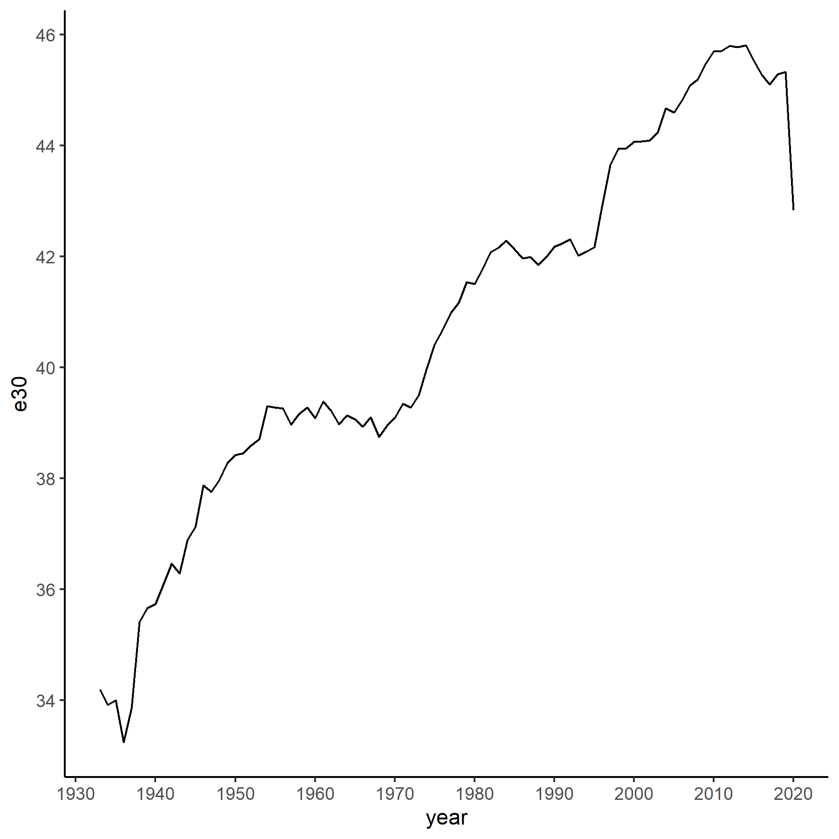

Figure 1. Time trajectory of remaining life expectancy at age 30 ($e_{30}$) for the United States Male, 1933-2020.

Source: Author’s calculation based on the HMD (2022).

Bergeron-Boucher et al. (2015) previously showed the results of the decomposition of changes in life expectancies for the year 1933-2010. We have extended the results by decomposing the changes in life expectancy of the US national population from 1933 to 2020 into components that contribute to the changes in background mortality, changes in mortality shift in older ages, and changes in mortality compression in older ages. The time trends of the three components are shown in Figure 2. The y-axis shows the contribution to the changes in life expectancy, with a positive value indicating an increase in life expectancy, and a negative value indicating a decrease in life expectancy. On the other hand, the x-axis shows the time period from 1933 to 2020. For clarity, we grouped the results into three-year groups. The solid dot denotes the total contribution to changes in life expectancy between adjacent groups of years.

Similar to the results presented in Bergeron-Boucher et al. (2015), the increases in life expectancy in the US, as observed in Figure 1, are the results of the interaction of the three components. Starting from 1936 to 1945, the increases in life expectancy are majorly the effect of the reduction of background mortality, with minor effects from the mortality shift at older ages. The mortality compression components offset the progress made by the other two components, although the scale is relatively small. From the periods 1945 to 1954 and 1972 to 1984, the life expectancy increases are the result of positive contributions from both the mortality shift component and mortality compression component. However, during the period 1954 to 1972, life expectancy first declined and then stagnated, with total contributions fluctuating around 0 (-0.34 years to 0.33 years). From 1984 to 1993, the positive contributions from both the mortality shifting components and mortality compression components are offset by the negative contributions from the background mortality components, resulting in less than 0.5 years of changes to life expectancy (ranging from -0.29 to 0.18 years). From 1993 to 1999, life expectancy experienced a stable increase of almost 2 years (1.94 years). Entering the first decade of the 21st century, the life expectancy started at a mere 0.13 years with the background mortality component offsetting progress made by the other two components, followed by a steady increase with all three positive components (a total of 1.5 years increases in 9 years). However, since 2010, which was not covered by the original Bergeron-Boucher paper, the life expectancy progress went back to the early 2000 level (a mere 0.10 years of increase). Since then, the US life expectancy has fallen by a total of almost 3 years (-3.00 years).

**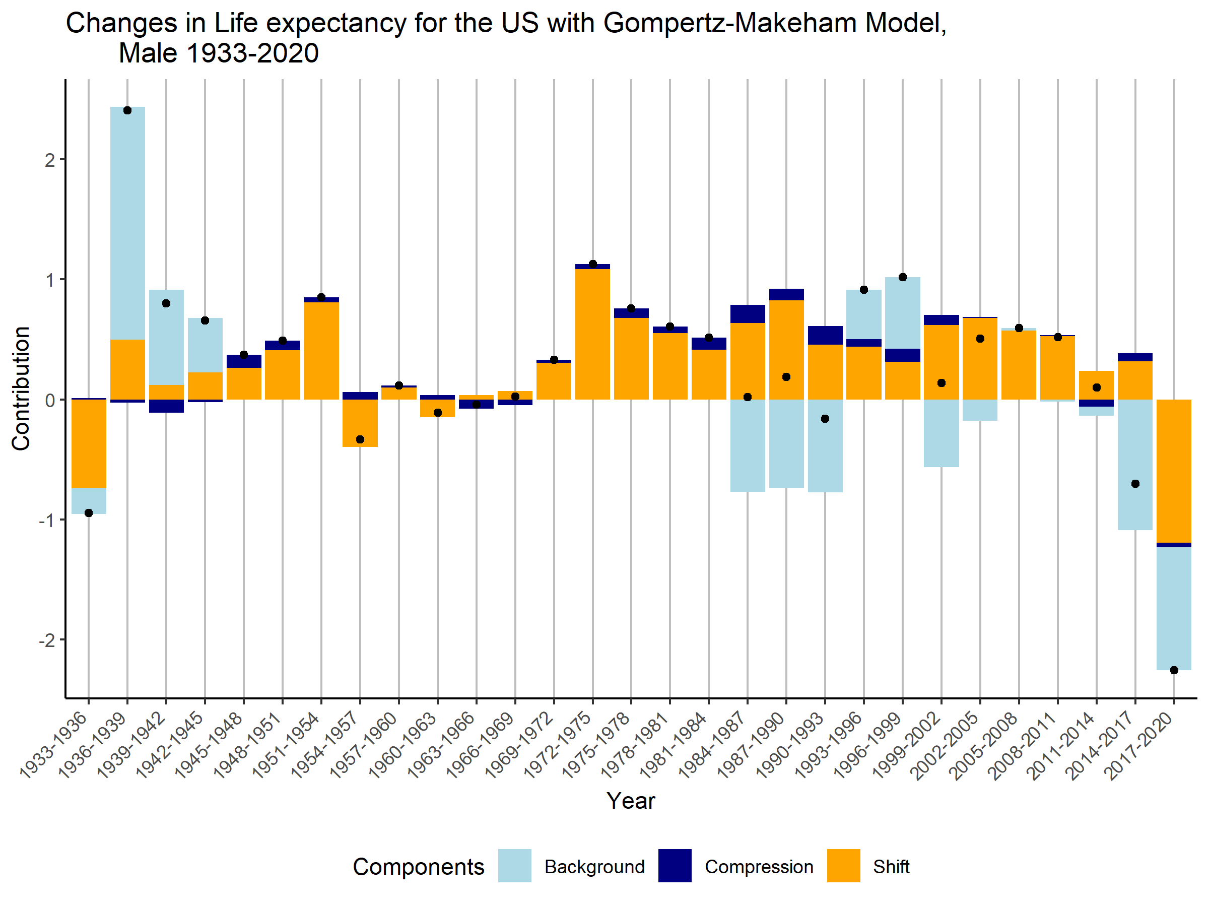**

Figure 2. Changes in life expectancy for the US with Gompertz-Makeham model, US male, 1933-2020. Replication and extension based on Bergeron-Boucher et al. (2015). Source: Author’s calculation based on HMD (2022) data.

**The US Sub-national**

Based on our results for the latter 10 years of the changes in life expectancy in the US, life expectancy is showing a steadily declining trajectory since 2008. To further measure the scale of this deterioration of the population health, we compared the changes in life expectancy and the contributions from the three components for different races in the US with the national population. This procedure will allow us to identify the leaders and laggers among the sub-populations that are contributing to the sharp decline in life expectancy in the US in the recent 10 years (3.65 years of decrease). Similar to Figure 2, we have presented the changes in life expectancy, and the contributions from background mortality changes, as well as mortality changes in compression and shift in older ages in Figure 3 for Black Americans, Native Americans, and Non-Hispanic White Americans from 2011 to 2020. For clarity of the results, we have grouped the results into three groups: 2011-2015, 2015-2019, and 2019-2020. We grouped 2019-2020 as a single group to quantify the impact of the COVID-19 pandemic to the

|  |  |
| --- | --- |
| C:\Users\u6897805\OneDrive - Australian National University\Currently Working!\Gompertz_Decomp\report\USA_Male_total,three_comp_2011-2020.png | C:\Users\u6897805\OneDrive - Australian National University\Currently Working!\Gompertz_Decomp\report\USA_Male_blacks,three_comp_2011-2020.png |
| C:\Users\u6897805\OneDrive - Australian National University\Currently Working!\Gompertz_Decomp\report\USA_Male_native,three_comp_2011-2020.png | C:\Users\u6897805\OneDrive - Australian National University\Currently Working!\Gompertz_Decomp\report\USA_Male_nonhis white,three_comp_2011-2020.png |

changes in life expectancy for different sub-population in the United States.

*Figure 3. Contributions to changes in life expectancy for Black Americans (top left), Native Americans (top right), US national (bottom left), and Non-Hispanic White Americans (bottom right), Male 2011-2020.*

*Source: Author’s calculation based on data from NCHS (2022).*

As observed in figure 3, different racial groups share a similar trend in the latest 10 years with life expectancy steadily declining. During the period 2015-2019, all three racial groups show a similar pattern with shift and compression components making positive changes to life expectancy while background mortality offset those positive changes, resulting in a decrease in life expectancies. At the same time, during the period 2019-2020, due to the impact on mortality from the global pandemic, all three components contributed to the decrease in life expectancy. However, the contributions from different components are different for each racial group. For instance, during the first year of the pandemic, the contributions

To further examine the differences from each component across different racial groups during the period 2011-2020, we present the contributions in Table 1. We can tell during the period 2011-2015, the changes in life expectancy for each racial group are relatively small since each component contributes relatively small values compared to the latter two periods. During the period 2015-2019, the Native Americans and Non-Hispanic White Americans suffered a larger loss in life expectancy from the background mortality component (beyond -1.40 years) in contrast to the national average (-1.27 years), while Black Americans lost relatively fewer life years (-1.18 years) from this component. However, Native Americans benefited from a hugely positive contribution from the mortality shift component (1.26 years). During the period 2019-2020, all racial groups suffered great negative contributions (ranging from -1.40 to -2.52 years) that lead to a decrease in life expectancy. Black Americans and Native Americans suffered less from background mortality changes compared to the national level and Non-Hispanic White males (beyond -2 years). For the mortality shift component, Black Americans and Native Americans have a higher contribution (contributions around -2.5 years) to the decrease in life expectancy compared to the national level (-1.06 years) and their Non-Hispanic white counterparts (-059 years). For the mortality compression components, one observation worth mentioning is that for Non-Hispanic White Americans, the contribution (0.61 years) from this component is positive throughout the year 2015-2020, and higher than the national average (0.40 years). At the same time, during the COVID-19 pandemic, the mortality compression component for Black Americans is positive and fairly consistent with the national level.

Table 1. Contributions from background mortality component (light blue), mortality compression component (navy blue), and mortality shift component (orange) to changes in life expectancy for different races of males in the US, 2011-2020.

|  |  |  |  |  |  |  |  |  |  |
| --- | --- | --- | --- | --- | --- | --- | --- | --- | --- |
| *Sub-populations/Year* | *2011-2015* | | | *2015-2019* | | | *2019-2020* | | |
| *Black Americans* | *-0.059* | *-0.211* | *0.334* | *-1.175* | *-0.044* | *0.372* | *-1.733* | *0.226* | *-2.498* |
| *Native Americans* | *-0.417* | *-0.398* | *0.268* | *-1.432* | *0.010* | *1.261* | *-1.409* | *-0.378* | *-2.597* |
| *Non-Hispanic White Americans* | *-0.329* | *-0.073* | *0.193* | *-1.450* | *0.236* | *0.459* | *-2.524* | *0.369* | *-0.586* |
| *US National* | *-0.191* | *-0.097* | *0.230* | *-1.273* | *0.180* | *0.513* | *-2.163* | *0.216* | *-1.063* |

**Discussion**

Our study first replicated the decomposition made by Bergeron-Boucher et al. (2015) on the contributions from background mortality, or extrinsic mortality, the contributions from mortality compression at older ages, and the contribution from mortality shift at older ages. We have shown the dynamics of three components across time that results in the changes in life expectancy in the US from 1933 to 2010. We have also extended the results to more recent years from 2010 to 2020. On top of that, we have performed the same decomposition on three different US sub-populations: Black Americans, Native Americans, and Non-Hispanic White Americans. We compared the contributions to changes in life expectancy for these racial groups from the three components against the US national level. We summarised two major points that add evidence to the research question and shed light on future research.

What the future holds in life expectancy change for the US? Based on the decomposition presented in Figure 2, we can say that the changes in life expectancy, in most cases, come from the positive contribution of mortality shift components. This is valuable evidence that provides clues to the future of life expectancy growth, and the possibility of an upper human lifespan. This is also the conclusion made by Bergeron-Boucher et al. (2015). With changes in life expectancy mostly driven by the mortality shift component, we might keep seeing the steady life expectancy improvements outlined in Oeppen & Vaupel (2002) and Vaupel et al. (2021). More evidence from other countries is needed to further test the hypothesis of an upper limit in human lifespan. However, our extension shed light on some possible public health challenge that lies ahead. The changes in lifespan expectancy can be negative with a high negative contribution from the background mortality component offsetting the positive contributions made by other components, according to our results. This phenomenon is visible in years around 1984-1993 and recent years. For the former period, the high extrinsic mortality might stem from the AIDS pandemic that plagued the United States during that time, with younger populations being the main target group (Kristensen et al., 2021). For the latter period, the background mortality components might come from the opioid crisis that results in an unusual number of deaths among younger generations and middle-aged populations (Couillard et al., 2021; Crimmins & Zhang, 2019). This public health crisis of excess deaths among young to middle-aged Americans is also being framed as the “death of despair” (Case & Deaton, 2021). The COVID pandemic has added an extra burden on reducing the high background mortality (Aburto et al., 2021). Since the results are only presented until the year 2020, the impact of COVID-19 is still heavy in the US. The near future of life expectancy growth in the United States is unlikely.

How do the changes in life expectancy among sub-populations in the US differ from the national level in recent years? Based on the results presented in Figure 3 and Table 1, we can conclude that there are complex dynamics that underlie the changes in life expectancy among different racial groups. To further explore these dynamics, data from longer series of time is needed. Nonetheless, the results analysed from the year 2011-2020 exhibit two points:

1. During the COVID-19 pandemic, Black Americans and Native Americans are heavily impacted at older ages, this can be seen from the excess contribution from the mortality shift component compared to the average, and positive mortality compression component for Black Americans. This occurrence could mean that more deaths are happening before the modal age of death and are concentrated in one specific age group.
2. Despite the excess mortality shown by the higher than average background mortality component, Non-Hispanic White Americans are still making progress in old-age survival improvements. This is shown by the positive contribution mortality compression component and mortality shift component from 2015-2020. Non-Hispanic White Americans might be less impacted by the COVID-19 pandemic at older ages based on the lower-than-average mortality shift component.

The relatively lower impact on older Non-Hispanic White Americans from COVID-19 in comparison to other minority racial groups will heavily impact the differences in the longevity outlook between the two. This is consistent with previous research (Aburto et al., 2022; Woolf et al., 2021; Woolf et al., 2022; Wrigley-Field 2020). However, the different levels of impact from the background mortality among different races, which mostly comes from younger and middle-aged, shows that there is still heterogeneity within the causes of mortality and would need further investigations.

This study could benefit from multiple ways of improvement. Firstly, the model this study utilized is relatively less complex compared to the more recently developed models, such as the Siler model (Siler, 1979), and the mixture model (Mazzucco et al., 2021) which quantifies premature mortality from old-age mortality. The model only accounts for ages 30 to age 110, which might not capture the mortality contribution from the population aged 30 and below. Secondly, the decomposition methods used in the Bergeron-Boucher (2015) paper and our study can separate changes in life expectancy into different meaningful components, which are descriptive. But despite that, the changes in life expectancy and its causal drivers are not identified by our methods. More statistically advanced methods such as differences in differences or instrumental variable methods might be needed to establish a causal link between certain factors within the population (education, healthcare coverage) and increase/decrease in life expectancy. The data from NCHS for different racial groups in the United States suffer from categorical errors since the race categories are self-identified. This would reduce the validity of the results. Adding measures of uncertainty in the comparisons among different races might contribute to the reliability of the results. Lastly, only three racial groups are examined from the year 2011-2020. More insights would be gained from the incorporation of longer series of data and more categories of race and ethnicity, such as adding the results for Asian Americans and Hispanic Americans.

**Conclusion**

Under the current mortality improvements, living to age 80 for many Americans is a very realistic expectation. Based on our results and discussion, more and more Americans will have this luxury. However, recent years have witnessed growing mortality among younger and middle-aged Americans which coincided with our results. For them, they will never get to experience the wonderful opportunities this world can offer them. Everybody counts or nobody counts. Action needs to be taken, particularly after the COVID-19 pandemic, to tackle young and middle age mortality, especially for minority groups.

**Reference**

Aburto, J. M., Kristensen, F. F., & Sharp, P. (2021). Black-white disparities during an epidemic: Life expectancy and lifespan disparity in the US, 1980–2000. Economics & Human Biology, 40, 100937. <https://doi.org/10.1016/j.ehb.2020.100937>

Aburto, J. M., Tilstra, A. M., Floridi, G., & Dowd, J. B. (2022). Significant impacts of the COVID-19 pandemic on race/ethnic differences in US mortality. Proceedings of the National Academy of Sciences, 119(35), e2205813119. <https://doi.org/10.1073/pnas.2205813119>

Aburto, J. M., Villavicencio, F., Basellini, U., Kjærgaard, S., & Vaupel, J. W. (2020). Dynamics of life expectancy and life span equality. Proceedings of the National Academy of Sciences, 117(10), 5250. <https://doi.org/10.1073/pnas.1915884117>

Andreev, E. M., Shkolnikov, V. M., & Begun, A. (2002). Algorithm for decomposition of differences between aggregate demographic measures and its application to life expectancies, healthy life expectancies, parity-progression ratios and total fertility rates. Demographic Research, 7(14), 499–522. <https://doi.org/10.4054/DemRes.2002.7.14>

Avendano, M., & Kawachi, I. (2014). Why Do Americans Have Shorter Life Expectancy and Worse Health Than Do People in Other High-Income Countries? Annual Review of Public Health, 35(1), 307–325. <https://doi.org/10.1146/annurev-publhealth-032013-182411>

Basellini, U., & Camarda, C. G. (2022). Explaining regional differences in mortality during the first wave of Covid-19 in Italy. Population Studies, 76(1), 99–118. <https://doi.org/10.1080/00324728.2021.1984551>

Basellini, U., Canudas-Romo, V., & Lenart, A. (2019). Location–Scale Models in Demography: A Useful Re-parameterization of Mortality Models. European Journal of Population, 35(4), 645–673. <https://doi.org/10.1007/s10680-018-9497-x>

Bergeron-Boucher, M.-P., Ebeling, M., & Canudas-Romo, V. (2015). Decomposing changes in life expectancy: Compression versus shifting mortality. Demographic Research, 33(14), 391–424. <https://doi.org/10.4054/DemRes.2015.33.14>

Brillinger, D. R. (1986). A Biometrics Invited Paper with Discussion: The Natural Variability of Vital Rates and Associated Statistics. Biometrics, 42(4), 693–734. JSTOR. <https://doi.org/10.2307/2530689>

Canudas-Romo, V. (2003). Decomposition methods in demography. Rozenberg Publishers Amsterdam.

Canudas-Romo, V. (2008). The modal age at death and the shifting mortality hypothesis. Demographic Research, 19, 1179–1204. JSTOR.

Canudas-Romo, V. (2010). Three measures of longevity: Time trends and record values. Demography, 47(2), 299–312. <https://doi.org/10.1353/dem.0.0098>

Case, A., & Deaton, A. (2021). Deaths of Despair and the Future of Capitalism. Princeton University Press.

Chiang, C. L. (1984). The life table and its applications (2333364; Original). R.E. Krieger Pub. Co.

Connor, H. (2022). John Graunt F.R.S. (1620-74): The founding father of human demography, epidemiology and vital statistics. Journal of Medical Biography, 09677720221079826. <https://doi.org/10.1177/09677720221079826>

Couillard, B. K., Foote, C. L., Gandhi, K., Meara, E., & Skinner, J. (2021). Rising Geographic Disparities in US Mortality. Journal of Economic Perspectives, 35(4), 123–146. <https://doi.org/10.1257/jep.35.4.123>

Crimmins, E. M., & Zhang, Y. S. (2019). Aging Populations, Mortality, and Life Expectancy. Annual Review of Sociology, 45(1), 69–89. <https://doi.org/10.1146/annurev-soc-073117-041351>

Cui, Q., Canudas-Romo, V., & Booth, H. (2019). The Mechanism Underlying Change in the Sex Gap in Life Expectancy at Birth: An Extended Decomposition. Demography, 56(6), 2307–2321. <https://doi.org/10.1007/s13524-019-00832-z>

Dwyer-Lindgren, L., Bertozzi-Villa, A., Stubbs, R. W., Morozoff, C., Mackenbach, J. P., van Lenthe, F. J., Mokdad, A. H., & Murray, C. J. L. (2017). Inequalities in Life Expectancy Among US Counties, 1980 to 2014: Temporal Trends and Key Drivers. JAMA Internal Medicine, 177(7), 1003–1011. <https://doi.org/10.1001/jamainternmed.2017.0918>

Fries, J. F. (1980). Aging, Natural Death, and the Compression of Morbidity. New England Journal of Medicine, 303(3), 130–135. <https://doi.org/10.1056/NEJM198007173030304>

Gompertz, B. (1825). On the nature of the function expressive of the law of human mortality, and on a new mode of determining the value of life contingencies. Philosophical Transactions of the Royal Society of London, 115, 513–583. <https://doi.org/10.1098/rstl.1825.0026>

HMD. (2022). HMD (Human Mortality Database). In HMD. Max Planck Institute for Demographic Research (Germany), University of California, Berkeley (USA), and French Institute for Demographic Studies (France); HMD. Available at: <http://www.mortality.org>

Ho, J. Y., & Hendi, A. S. (2018). Recent trends in life expectancy across high income countries: Retrospective observational study. BMJ, 362, k2562. <https://doi.org/10.1136/bmj.k2562>

Horiuchi, S., Ouellette, N., Cheung, S. L. K., & Robine, J.-M. (2013). Modal age at death: Lifespan indicator in the era of longevity extension. Vienna Yearbook of Population Research, 11, 37–69. JSTOR.

Horiuchi, S., Wilmoth, J. R., & Pletcher, S. D. (2008). A decomposition method based on a model of continuous change. Demography, 45(4), 785–801. <https://doi.org/10.1353/dem.0.0033>

Janssen, F., & de Beer, J. (2019). The timing of the transition from mortality compression to mortality delay in Europe, Japan and the United States. Genus, 75(1), 10. <https://doi.org/10.1186/s41118-019-0057-y>

Luy, M., Di Giulio, P., Di Lego, V., Lazarevič, P., & Sauerberg, M. (2020). Life Expectancy: Frequently Used, but Hardly Understood. Gerontology, 66(1), 95–104. <https://doi.org/10.1159/000500955>

Makeham, W. M. (1867). On the Law of Mortality. Journal of the Institute of Actuaries (1866), 13(6), 325–358. Cambridge Core. <https://doi.org/10.1017/S2046166600003238>

Mazzuco, S., Suhrcke, M., & Zanotto, L. (2021). How to measure premature mortality? A proposal combining “relative” and “absolute” approaches. Population Health Metrics, 19(1), 41. <https://doi.org/10.1186/s12963-021-00267-y>

McKeown, R. E. (2009). The Epidemiologic Transition: Changing Patterns of Mortality and Population Dynamics. American Journal of Lifestyle Medicine, 3(1\_suppl), 19S-26S. <https://doi.org/10.1177/1559827609335350>

Missov, T. I., Lenart, A., Nemeth, L., Canudas Romo, V., & Vaupel, J. W. (2015). The Gompertz force of mortality in terms of the modal age at death. Demographic Research, S8(36), 1031–1048.

Modig, K., Rau, R., & Ahlbom, A. (2020). Life expectancy: What does it measure? BMJ Open, 10(7), e035932. <https://doi.org/10.1136/bmjopen-2019-035932>

Newton, I. (1704). Opticks: Or, A treatise of the reflections, refractions, inflexions and colours of light. Printed for Sam. Smith, and Benj. Walford. Retrieved from <https://doi.org/10.5479/sil.302475.39088000644674>

Oeppen, J., & Vaupel, J. W. (2002). Broken Limits to Life Expectancy. Science, 296(5570), 1029. <https://doi.org/10.1126/science.1069675>

Omran, A. R. (2005). The epidemiologic transition: A theory of the epidemiology of population change. 1971. The Milbank Quarterly, 83(4), 731–757. PubMed. <https://doi.org/10.1111/j.1468-0009.2005.00398.x>

Ouellette, N., & Bourbeau, R. (2011). Changes in the age-at-death distribution in four low mortality countries: A nonparametric approach. Demographic Research, 25(19), 595–628. <https://doi.org/10.4054/DemRes.2011.25.19>

Preston, S. H., & Vierboom, Y. C. (2021). Excess mortality in the United States in the 21st century. Proceedings of the National Academy of Sciences, 118(16), e2024850118. <https://doi.org/10.1073/pnas.2024850118>

Preston, S., Heuveline, P., & Guillot, M. (2000). Demography: Measuring and modeling population processes (1st ed.). Wiley-Blackwell.

R Core Team. (2022). R: A language and environment for statistical computing. The Comprehensive R Archive Network. <https://cran.R-project.org/>

Rizzi, S., Gampe, J., & Eilers, P. H. C. (2015). Efficient Estimation of Smooth Distributions From Coarsely Grouped Data. American Journal of Epidemiology, 182(2), 138–147. <https://doi.org/10.1093/aje/kwv020>

Schlüter, B.-S., Masquelier, B., & Camarda, C. G. (2022). Heterogeneity in subnational mortality in the context of the COVID-19 pandemic: The case of Belgian districts in 2020. Archives of Public Health, 80(1), 130. <https://doi.org/10.1186/s13690-022-00874-7>

Shkolnikov, V. M., Andreev, E. M., Zhang, Z., Oeppen, J., & Vaupel, J. W. (2011). Losses of Expected Lifetime in the United States and Other Developed Countries: Methods and Empirical Analyses. Demography, 48(1), 211–239. <https://doi.org/10.1007/s13524-011-0015-6>

Silcocks, P. B. S., Jenner, D. A., & Reza, R. (2001). Life expectancy as a summary of mortality in a population: Statistical considerations and suitability for use by health authorities. Journal of Epidemiology and Community Health, 55(1), 38. <https://doi.org/10.1136/jech.55.1.38>

Siler, W. (1979). A Competing-Risk Model for Animal Mortality. Ecology, 60(4), 750–757. <https://doi.org/10.2307/1936612>

Tabeau, E. (2001). A Review of Demographic Forecasting Models for Mortality. In E. Tabeau, A. van den Berg Jeths, & C. Heathcote (Eds.), Forecasting Mortality in Developed Countries: Insights from a Statistical, Demographic and Epidemiological Perspective (pp. 1–32). Springer Netherlands. <https://doi.org/10.1007/0-306-47562-6_1>

U.S. Census Bureau & CDC’s National Center for Health Statistics. (2022). Single-race Population Estimates, United States, 2010-2020. July 1st resident population by state, age, sex, single-race, and Hispanic origin, on CDC WONDER Online Database. (July 27, 2021). <http://wonder.cdc.gov/single-race-single-year-v2020.html>

Vallin, J., & Meslé, F. (2009). The Segmented Trend Line of Highest Life Expectancies. Population and Development Review, 35(1), 159–187. <https://doi.org/10.1111/j.1728-4457.2009.00264.x>

Vaupel, J. W. (1986). How Change in Age-specific Mortality Affects Life Expectancy. Population Studies, 40(1), 147–157. <https://doi.org/10.1080/0032472031000141896>

Vaupel, J. W., Villavicencio, F., & Bergeron-Boucher, M.-P. (2021). Demographic perspectives on the rise of longevity. Proceedings of the National Academy of Sciences, 118(9), e2019536118. <https://doi.org/10.1073/pnas.2019536118>

Vaupel, J. W., Zhang, Z., & van Raalte, A. A. (2011). Life expectancy and disparity: An international comparison of life table data. BMJ Open, 1(1), e000128. <https://doi.org/10.1136/bmjopen-2011-000128>

Vaupel, J. W., & Canudas-Romo, V. (2003). Decomposing change in life expectancy: A bouquet of formulas in honor of Nathan Keyfitz’s 90th birthday. Demography, 40(2), 201–216. <https://doi.org/10.1353/dem.2003.0018>

Wilmoth, J. R., & Horiuchi, S. (1999). Rectangularization revisited: Variability of age at death within human populations\*. Demography, 36(4), 475–495. <https://doi.org/10.2307/2648085>

Woolf, S. H., & Schoomaker, H. (2019). Life Expectancy and Mortality Rates in the United States, 1959-2017. JAMA, 322(20), 1996–2016. <https://doi.org/10.1001/jama.2019.16932>

Woolf, S. H., Masters, R. K., & Aron, L. Y. (2021). Effect of the covid-19 pandemic in 2020 on life expectancy across populations in the USA and other high income countries: Simulations of provisional mortality data. BMJ, 373, n1343. <https://doi.org/10.1136/bmj.n1343>

Woolf, S. H., Masters, R. K., & Aron, L. Y. (2022). Changes in Life Expectancy Between 2019 and 2020 in the US and 21 Peer Countries. JAMA Network Open, 5(4), e227067–e227067. <https://doi.org/10.1001/jamanetworkopen.2022.7067>

Wrigley-Field, E. (2020). US racial inequality may be as deadly as COVID-19. Proceedings of the National Academy of Sciences, 117(36), 21854. <https://doi.org/10.1073/pnas.2014750117>

**Appendix**

**Methodological Details**

1. Maximum Likelihood Estimation

For the estimation of the age-specific mortality rate ($μ_{x}$), we utilized the maximum likelihood estimation to select the best-fitted parameters for the given mortality information. The likelihood equation has been developed by Missov et al. (2015), which wrote:

$$\ln{L}\left(θ | D_{x},E_{x}\right)∝ \sum_{0}^{ω}{\left\{D_{x}\ln{(μ_{x}\left(θ\right)-E_{x}μ_{x}\left(θ\right)}\right\} }.$$

The $θ$ represents a vector of model parameters of our interest. The notation $D_{x}$, and notation $E_{x}$ represents the number of deaths at each age, and population exposure at each age, respectively. The procedure was carried out in *R* with the package *DEoptim*.

1. Discrete Approximation of the Derivatives

The approximation procedures are adopted from the paper by Vaupel & Canudas-Romo (2003) with the assumption that the changes in demographic function are a constant growth. The derivative equation is shown for a function $v(t)$ at time $t$:

$\dot{v}(t+\frac{h}{2})≈\frac{\ln\left[\frac{v\left(t+h\right)}{v\left(t\right)}\right]}{h}v\left(t+\frac{h}{2}\right)$.

with the mid-point function ($v(t+\frac{h}{2}$) )writes:

$v\left(t+\frac{h}{2}\right)≈{\left[v\left(t\right)v\left(t+h\right)\right]}^{\frac{1}{2}}$.